

User Manual
Employee Letter Module
www.flowhcm.com



Contents
Employee Letter 3
Candidate Letters 5
Letter Approvals 7
Letter Setup 8
Letter Data 9
Letter Content 11
Custom Variables 13

Employee Letter

- Navigate to Others Tab and click Letters Module
- Move to Employee Letters tab, click on Create letter button
- Select Letter setup and Employee from dropdown
- Define the Email and Save document settings
- Toggle for Footer, Header and Page Number are given
- Press preview to view the letter if any changes are required, then click save
- Records will be saved in the grid, user can click on action button for required actions

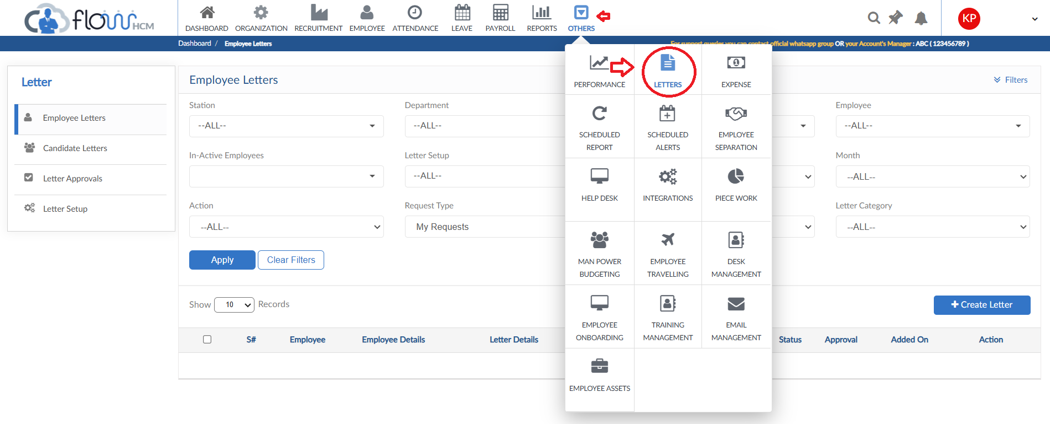
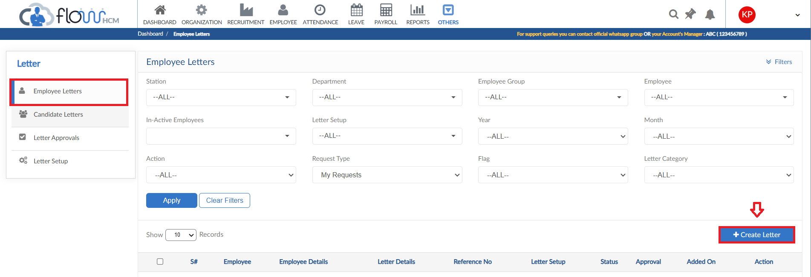

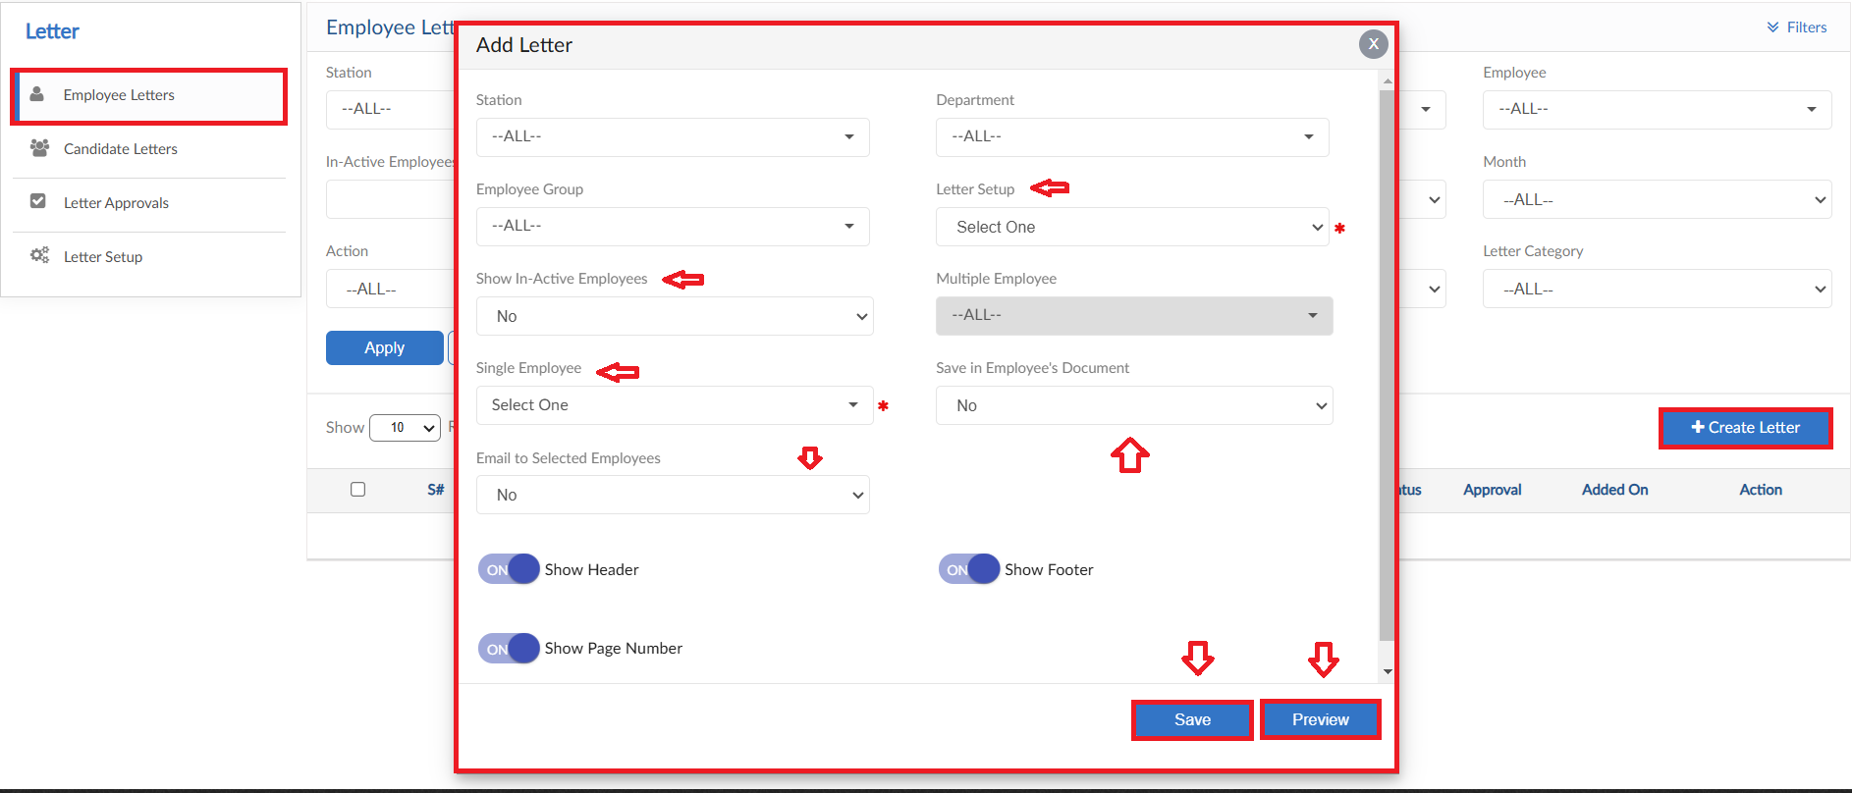
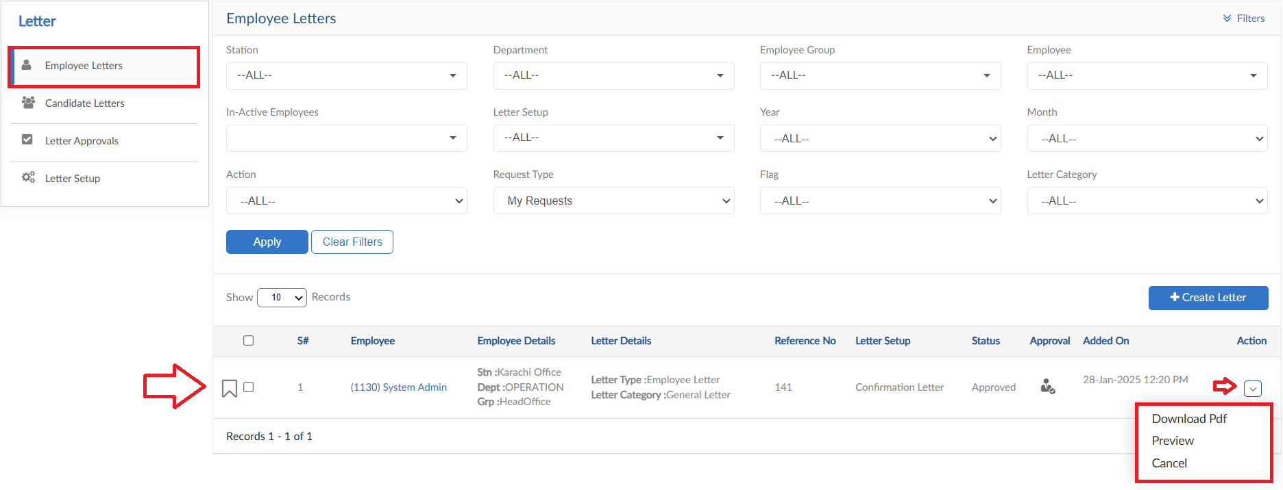

Candidate Letters

- Move to Candidate Letters tab, click on Create letter button
- Select Candidate and Letter setup from dropdown
- Define the Email settings
- Select Expected Line Manager and Joining Date
- Toggle for Footer, Header and Page Number are given
- Press preview to view the letter if any changes are required, then click save
- Records will be saved in the grid, user can click on action button for required actions

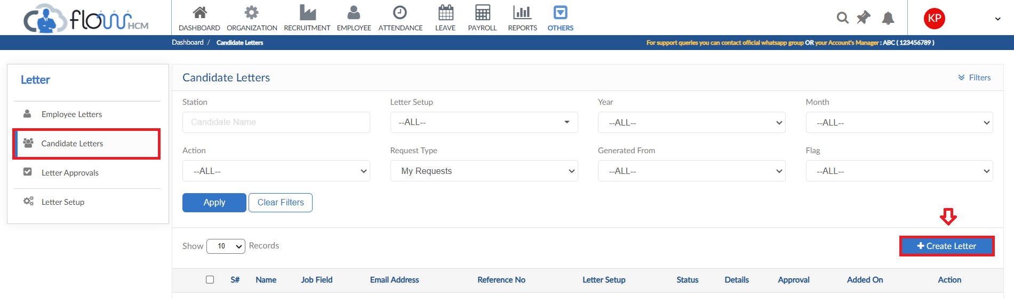
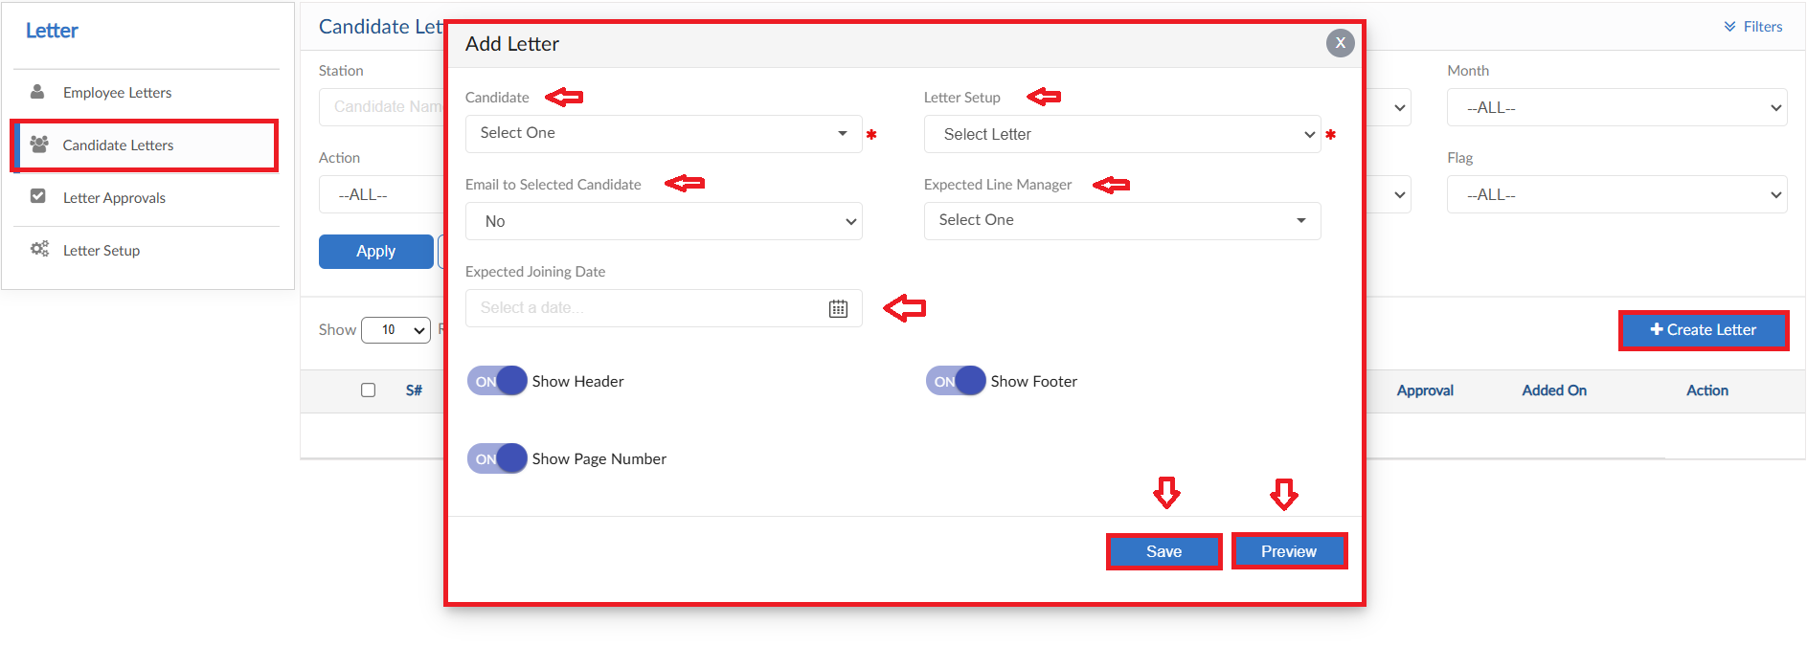
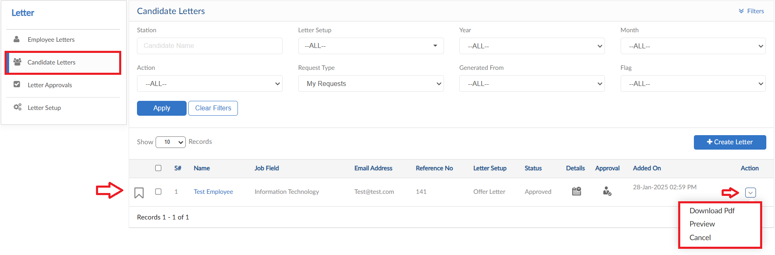

Letter Approvals

- Moving to next tab that is Letter Approvals
- This tab will show the list of approvals
- Providing further actions to be taken against the request

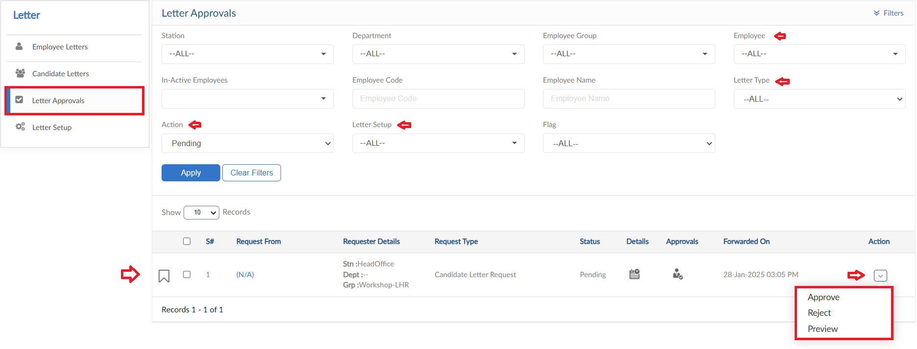

Letter Setup

- Move to next tab Letter Setup
- Consists of Multiple options for Employee Letters
- Letter Data and its content
- Custom variables option for letters

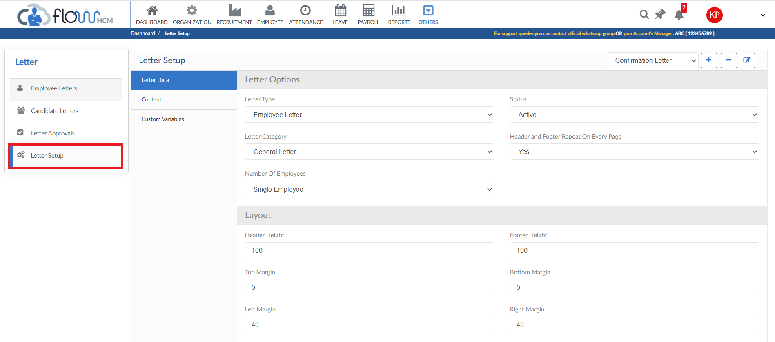

Letter Data
- In this tab data of the letters will be defined
- To add a new Letter Setup, click on Plus (+) sign a pop will be visible, enter Setup name and select letter type then click on save button
- To delete any Letter Setup, click on Minus (-) sign a confirmation pop up will be visible, enter YES then click on Yes button
- To update any Letter Setup Title, click on edit button a pop up will be visible, enter the title and then click on UPDATE button
- In Letter Options configure all the settings for the Letter Setup
- Configure the layout of the letter and select approval hierarchy
- Select alerts for Submission/Approval of a Letter
- Select either to integrate with other module or not and then save

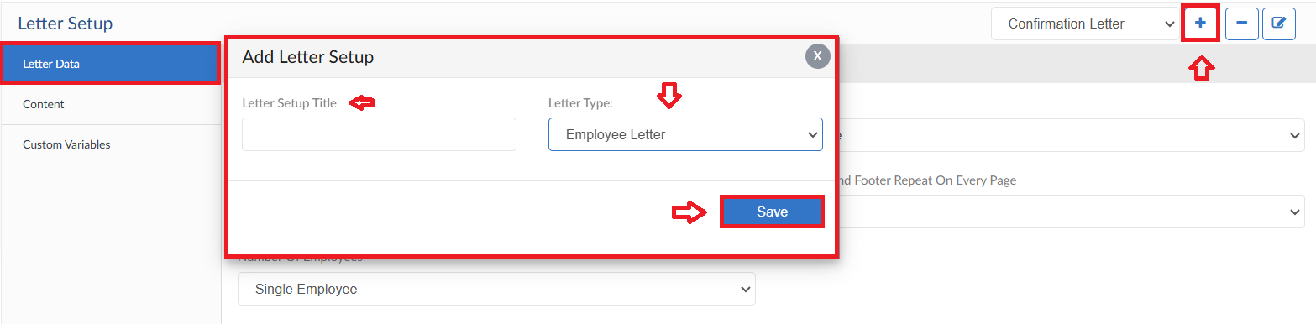
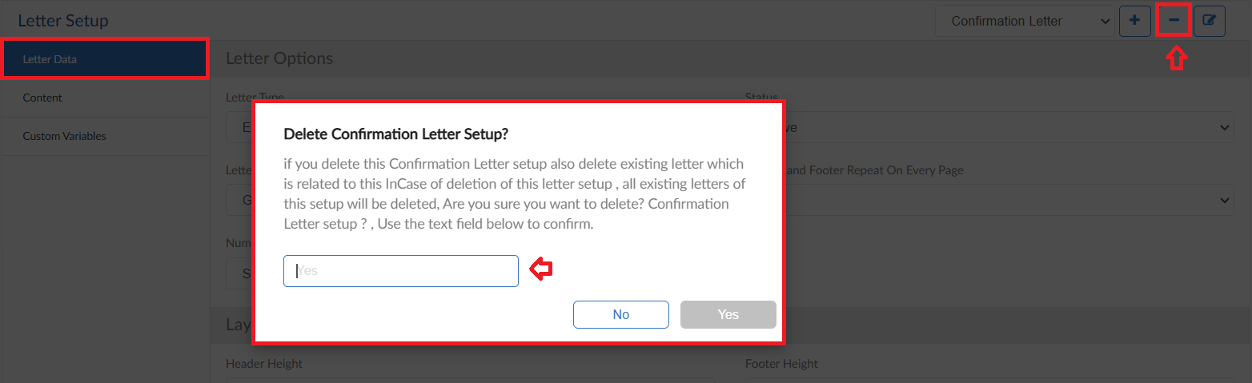
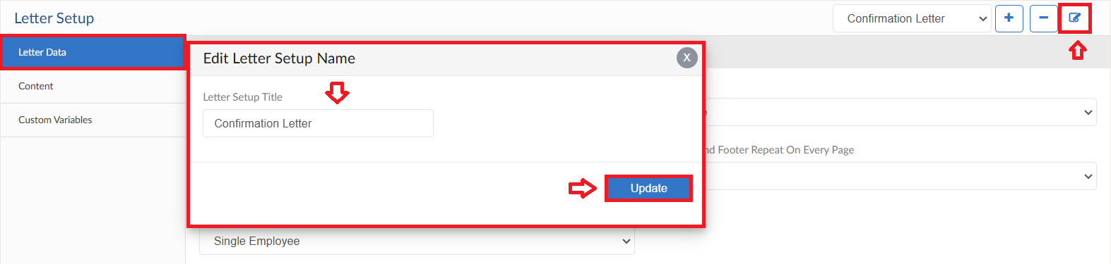
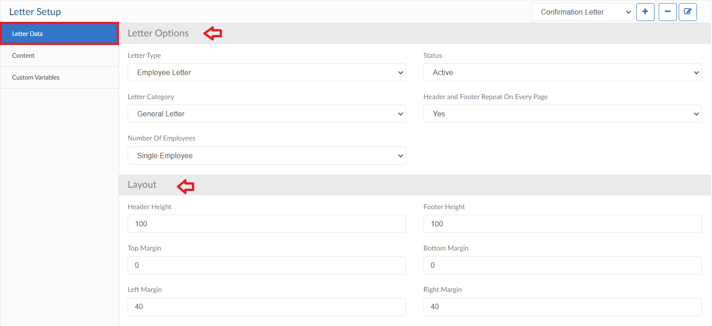
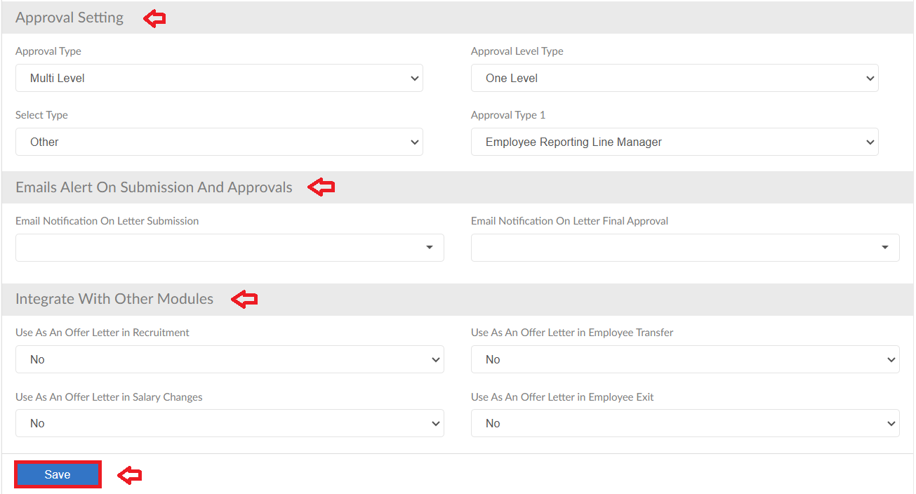

Letter Content
- Moving to next tab that is Content
- Set the details/logo/image needed in Header and Footer of the letter
- Select data and fields required in the body format of the letter
- Select preview option to see if any changes are required then click save

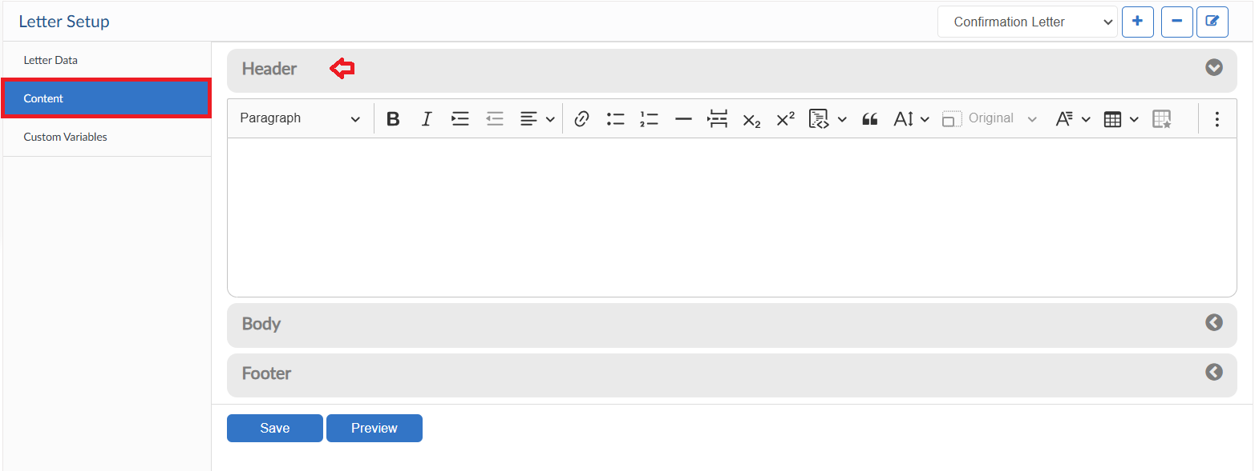
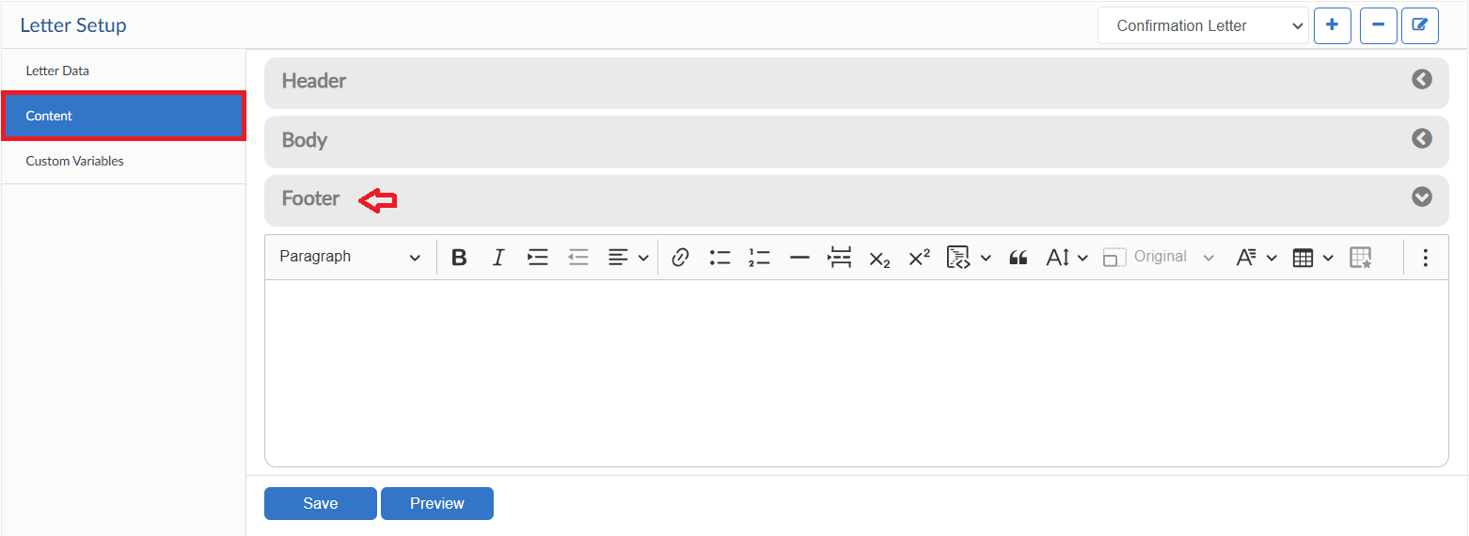
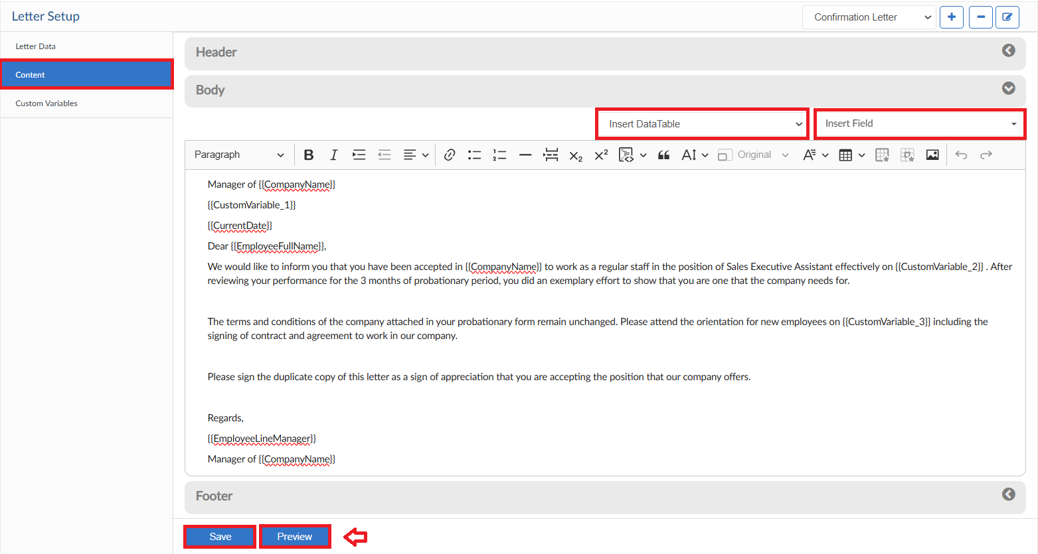

Custom Variables
- Next tab is of Custom Variables
- Gives option to add other fields or data in the format as a Customized Format
- Set the required fields and then click save to appear on format

